
SRM Institute of Science and Technology
College of Engineering and Technology
School of Computing
B1 - SET A
DEPARTMENT OFCOMPUTING TECHNOLOGIES
SRM Nagar, Kattankulathur – 603203, Chengalpattu District, Tamilnadu
Academic Year: 2021-2022 (EVEN)
Test: CLAT-1 Date: 4-4-2022
Course Code & Title: 18CSC205J: Operating systems Duration: 1 Period
Year & Sem: II & IV Max. Marks: 25 Marks

Course Outcomes (CO): |  |  |  |  |  |  | At the end of this course, learners will be able to:
CO-1 : |  | Express the fundamental concepts in operating system
Program Outcomes (PO)
1 | 2 |  | 3 | 4 | 5 | 6 |  | 7 | 8 | 9 | 10 | 11 | 12 | PSO
Engineering Knowledge | Problem Analysis |  | Design & Development | Analysis, Design, Research | Modern Tool Usage | Society & Culture |  | Environment & Sustainability | Ethics | Individual & Team Work | Communication | Project Mgt. & Finance | Life Long Learning | PSO - 1 | PSO - 2 | PSO – 3
3 |  |  | 3 |  |  |  |  |  |  |  |  |  |  | 2

Part - A
(5 x 1 = 5 Marks) Instructions: Answer all
Q. No | Question |  | Marks | BL | CO | PO | PI Code
1 | Time Sharing technique handles  a) Single Interactive Job b) Multiple Iterative Job  c) Recent Interactive Job d) Old Interactive Job |  | 1 | 1 | 1 | 1 | 1.6.1
2 | Interrupts make an Operating System more  a) Secure b) Slow c) Fast d) Flexible |  | 1 | 1 | 1 | 1 | 1.6.1
3 | Work can be ________ while using multiprogramming batch processing.  a) Rigid b) Expensive c) Reliable d) Flexible |  | 1 | 1 | 1 | 1 | 1.6.1
4 | When you start up the computer the boot up storage at which the BIOS versions manufacturer and data are displayed on the monitor is called  a) Bootstrap b). Power on self-test (POST)  c) System configuration d). Kernel loading |  | 1 | 1 | 1 | 1 | 1.6.1
5 | What is dispatch latency?  A. The time taken by the dispatcher to stop one process and start another  B. The time taken by the processor to write a file into disk  C. The whole time taken by all processor  D. None of Above |  | 1 | 1 | 1 | 1 | 1.6.1
Part – B
(5 x 4 = 20 Marks) Instructions: Answer any 5
6 |  | Compare Modes of operation in operating system.  - User Mode  - User program executes in user mode  - Certain areas of memory are protected from user access  - Certain instructions may not be executed  - Kernel Mode  - Monitor executes in kernel mode  - Privileged instructions may be executed  - Protected areas of memory may be accessed | 4 | 4 | 1 | 2 | 2.6.4
7 |  | Write short notes on Multiprogramming  Multiprogramming  - also known as multitasking  - memory is expanded to hold three, four, or more programs and switch among all of them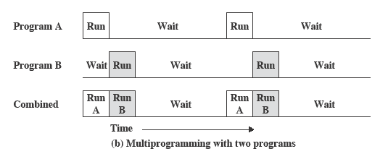  There must be enough memory to hold the OS (resident monitor) and one user program  When one job needs to wait for I/O, the processor can switch to the other job, which is likely not waiting for I/O | 4 | 3 | 1 | 1 | 1.7.1
8 |  | Relate Process Control Block with respect to process.  Information associated with each process  (also called task control block)  - Process state – running, waiting, etc  - Program counter – location of instruction to next execute  - CPU registers – contents of all process-centric registers  - CPU scheduling information- priorities, scheduling queue pointers  - Memory-management information – memory allocated to the process  - Accounting information – CPU used, clock time elapsed since start, time limits  - I/O status information – I/O devices allocated to process, list of open files | 4 | 3 | 1 | 2 | 2.6.2
9 |  | With a neat sketch interpret addition of medium-term scheduling  Medium-term scheduler can be added if degree of multiple programming needs to decrease  - Remove process from memory, store on disk, bring back in from disk to continue execution: swapping  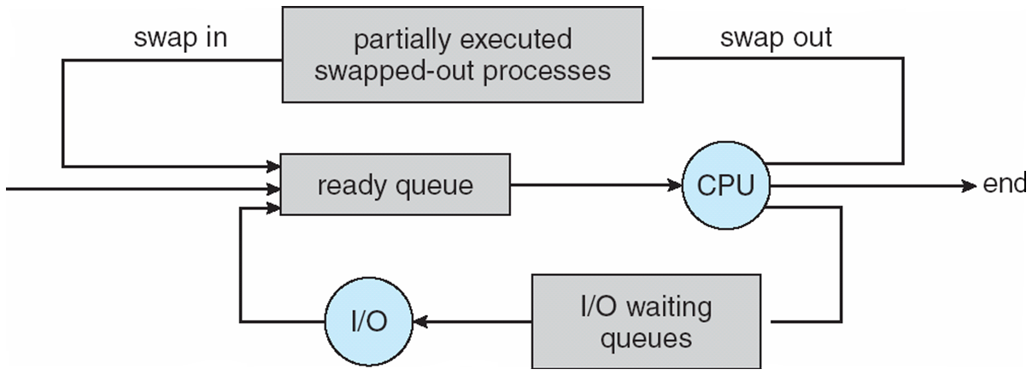 | 4 | 3 | 1 | 3 | 2.6.2
10 |  | Illustrate inter-process communication  - Processes within a system may be independent or cooperating  - Cooperating process can affect or be affected by other processes, including sharing data  - Reasons for cooperating processes:  - Information sharing  - Computation speedup  - Modularity  - Convenience  - Cooperating processes need interprocess communication (IPC)  - Two models of IPC  - Shared memory  - Message passing | 4 | 2 | 1 | 1 | 1.7.1
11 |  | With a suitable example illustrate IPC POSIX Producer  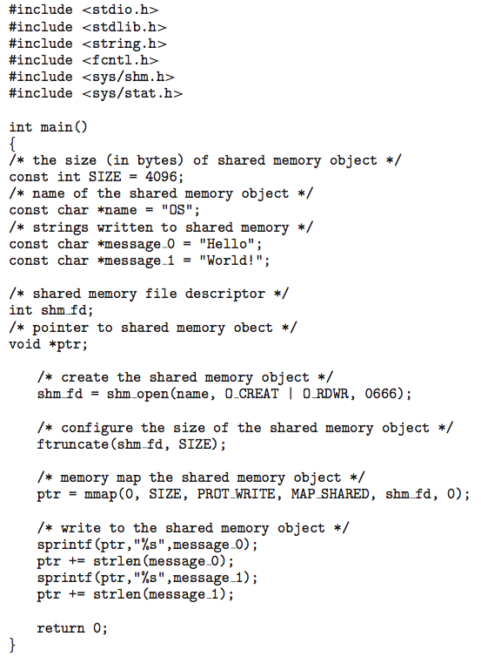 | 4 | 2 | 1 | 2 | 1.7.1

